LEARN TO RIDE

High-quality Western and English riding lessons, focusing on safety and including instruction on horse care, saddling a horse, and other aspects of horsemanship.

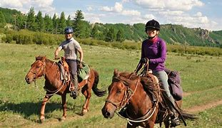

* Novice to advanced instruction for children and adults
* Indoor and outdoor arenas
* $40 per hour for private lessons; $25 for group lessons

## CALL TRI-VALLEY STABLES AT 555-2030 TODAY?